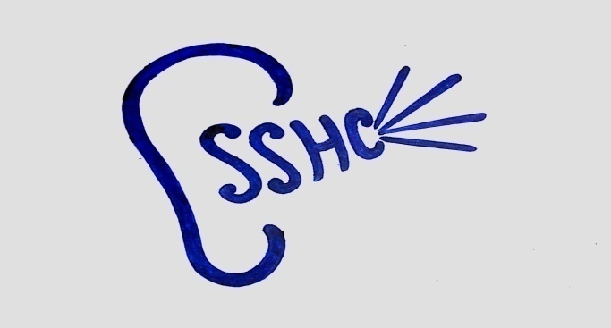 Siliguri Speech & Hearing Clinic
2 No,Rashbihari Sarani,Hakimpara,Siliguri,Darjeeling-734001,(W.B.)Ph-7364079526
www.siligurispeechandhearingclinic.yolasite.com

Ref.No-SSHC/EX.CFT/02/19

TO WHOM IT MAY CONCERN

This is to certify that Mr. Soven Kumar Sahoo has been working at Siliguri Speech & Hearing Clinic, as a full time Audiologist since 3rd of May 2018 till date.

He has a good professional skill in work with speech & hearing disorder population. He can administer all audiological tests independently & also
very regular in attendance.

He bears good moral character.

We wish him all the best for his career.

Date …………………
Authorised signatory

(Paromita Swarnakar)
Proprietor

